PRACTICE TASK CLASS -1
- creating and deleting of single and multiple files.
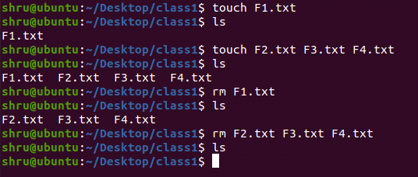
- creating and deleting of single and multiple directory.
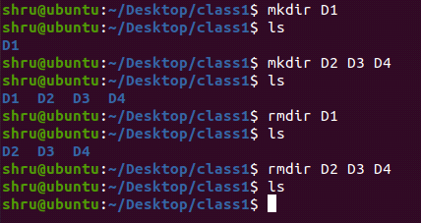
- date and help command
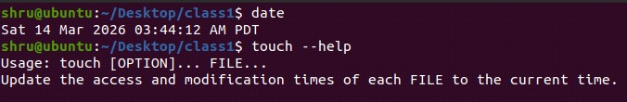
- Change directory (cd)
